UML OBJECT DIAGRAMS – 1

1.BOOK SYSTEM

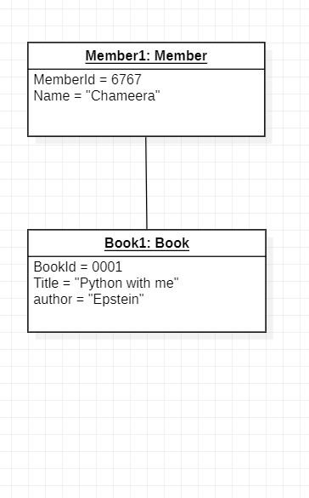

2. BANKING/ATM

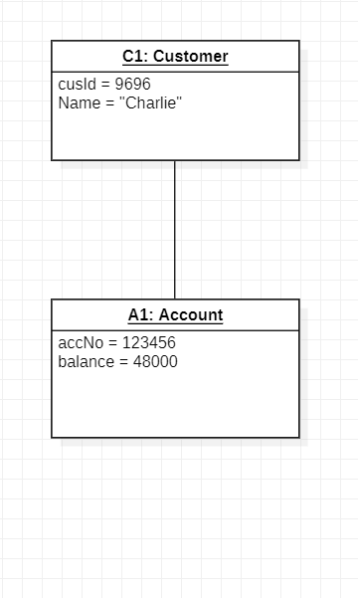

3.ORDER SYSTEM

